October 7, 2021

Dear Class of 2022 Families:

We have a lot going on with the Class of 2022 right now and wanted to put everything in one place for your review.

Senior Portraits November Dates
November 4, 5 and 8 from 3:00-8:00 pm. This is the last opportunity for senior portraits at the school.

If you wish to use the photographer provided tuxedos, drapes or cap and gown, please note this will be shared clothing and students must bring this signed waiver with them to the shoot.

Please sign up for your session time here:
pickatime.com/vosphoto/lakebraddockss

If you have any questions, feel free to reach out to mailto:seniors@vosphoto.com.

Yearbooks and Senior Ads
Please see the information in the following flyers regarding yearbooks and senior ads:
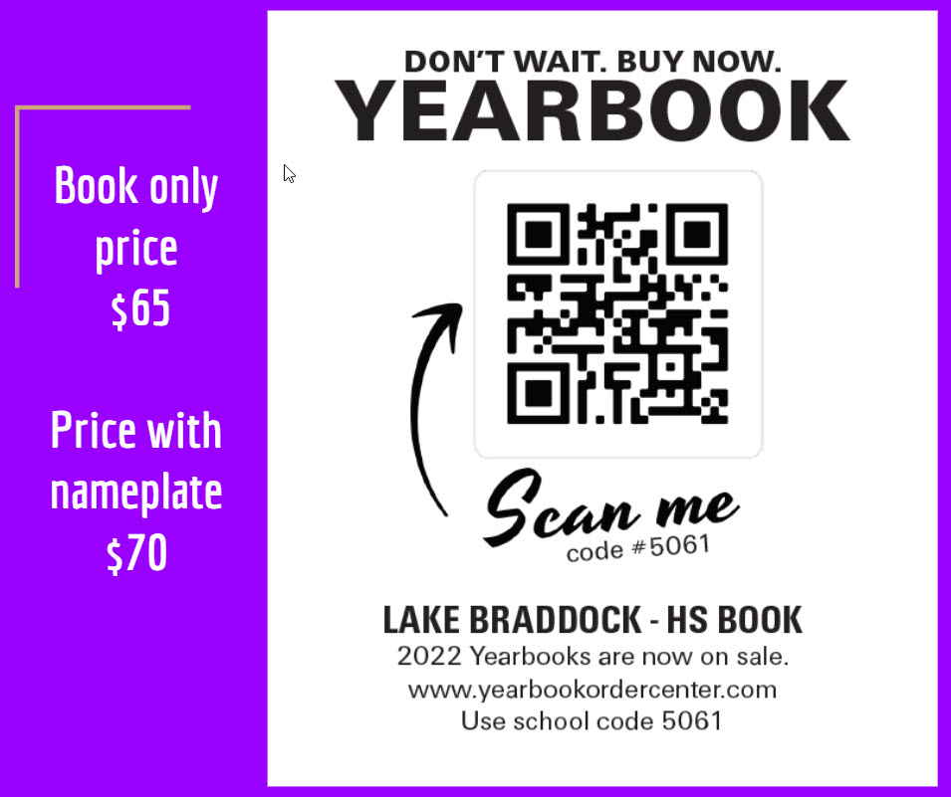’

Parking Spot Painting
Parking spot painting will be on Oct 11th at 10am. Students who already have a valid parking pass to park on campus can pay an additional $25 to paint a parking spot. This will assign/claim their parking spot for the rest of the year. To sign up please have your student visit this link. Payment can be made through MySchoolBucks. Please pay by 3pm on October 8th. Students must supply their own paint/painting supplies and be prepared to paint the spot back to black at the end of the year. Parking spot claiming is first come, first serve on Monday Oct 11th. Students can arrive early to claim their spot but must wait until 10am to paint.

Class of 2022 Schoology Group
Have your senior join the class of 2022 Schoology group for all of the most up to date information! The group code is: WWFX-8766-FHNJ6

Graduation Announcements, Caps and Gowns, and More from Herff Jones
Please see the information from Herff Jones in the flyer below and on our website (waiting for link from Laura). Note that appointments are available next week for in-person ordering at LBSS.

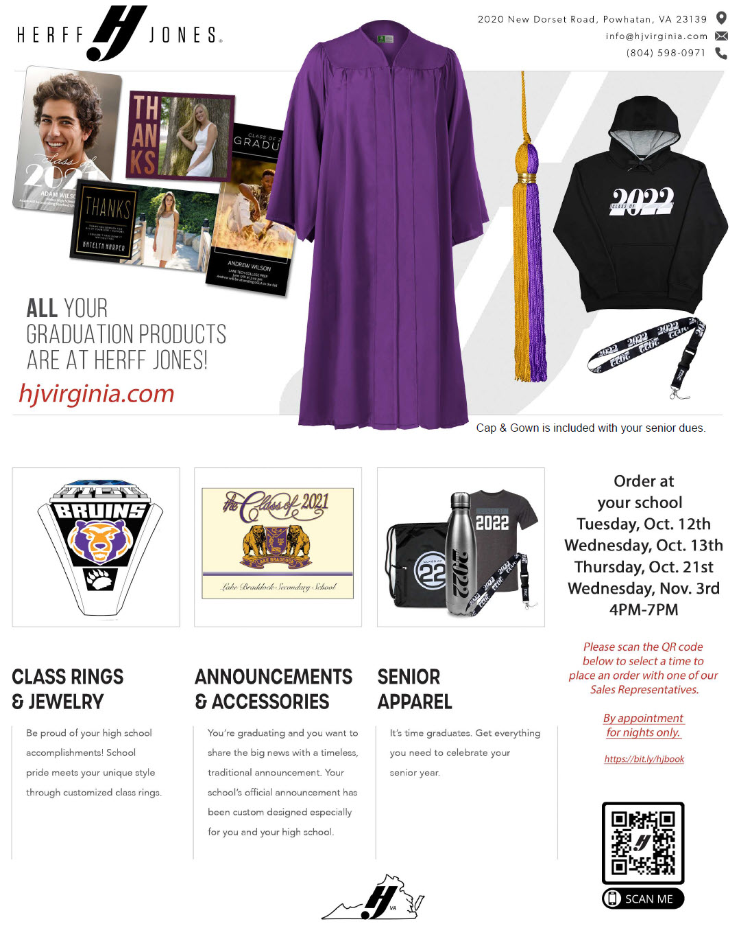

As we move towards graduation on June 6, please let us know if you have any questions or we can help in any way.

Class of 2022 Sponsors: Ms. Daniela Daniels and Ms. Amanda Moreland
Class of 2022 Administrators: Mr. Darryl Johnson and Ms. Alison Reeves

Sincerely,

Daniel W. Smith, Ed.D.
Principal

